

**Faculty of engineering - Shoubra Benha University**

# Research Article / Research Project / Literature Review

in fulfillment of the requirements of

|  |  |
| --- | --- |
| **Department** | **Engineering Mathematics and Physics** |
| **Division** |  |
| **Academic Year** | **2019-2020 Preparatory** |
| **Course name** | **Computer** |
| **Course code** | **ECE001** |

**Title: -**

**Artificial Intelligence**

By: **Nagy Nabil Mohamed Eraky**

|  |  |  |  |
| --- | --- | --- | --- |
|  | Name | Edu mail | B.N |
| 1 | ناجي نبيل محمد عراقي نورالدين | [nagy196100@feng.bu.edu.eg](mailto:nagy196100@feng.bu.edu.eg) | **977** |

## Approved by:

|  |  |
| --- | --- |
| Examiners committee | Signature |
| **Dr.Ahmed Bayoumi** |  |
| **Dr.Shady Elmashad** |  |
| **Dr. Abdelhamid Attaby** |  |

# Summary of the application

**What is Artificial Intelligence?**   
Artificial intelligence (AI) is an important branch of computer science,  
his mission is building smart machines capable to do tasks that require human intelligence, science fiction always imagine AL as robots with human- like characteristics, it can be anything from Google's search algorithms, al make it possible for machine to learn from experience as human being, Most AI examples that you hear about today, from chess-playing computers to self-driving cars – rely heavily on deep learning and natural language processing

**It can be classified into,**

* Narrow AI
* Artificial General Intelligence (AGI)

Artificial Intelligence makes the future today by its applications in all human activities like in Manufacturing, Education, and Customer Service

as we see around us AL works in so many types of industry or human being activity, small example computer vision for detection and classification of various “safety events,” this small device can know which way the driver is looking as he operates the vehicle, how fast he’s driving, where he’s driving, locations of the people around him, It aims to reduce any possible chance for accidents.

Artificial Intelligence history, Artificial intelligence was coined in 1956 but it has become more popular today because of increasing in data volumes, advanced algorithms, and improvements in computing power and storage.

**What makes a machine intelligent?**

* Thinking humanly
* Thinking rationally
* Acting humanly
* Acting rationally

# Screenshots

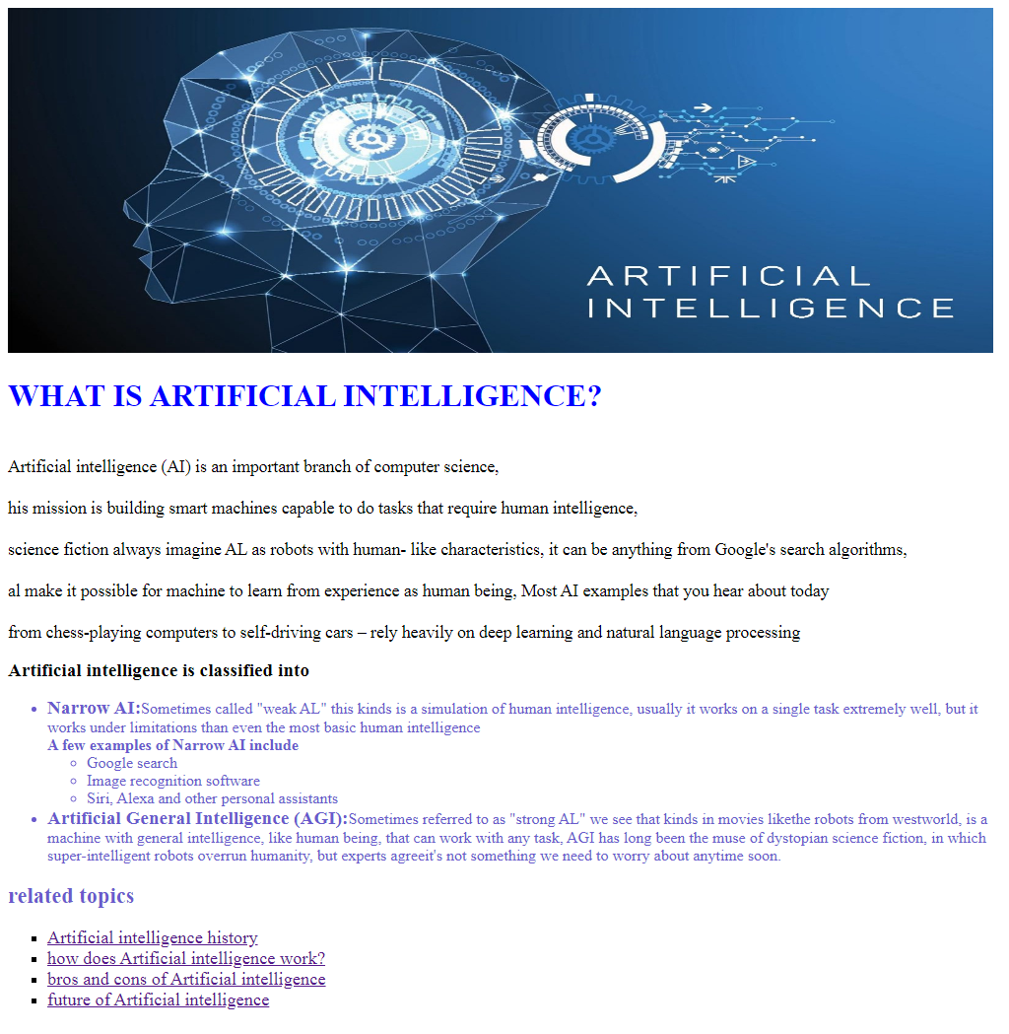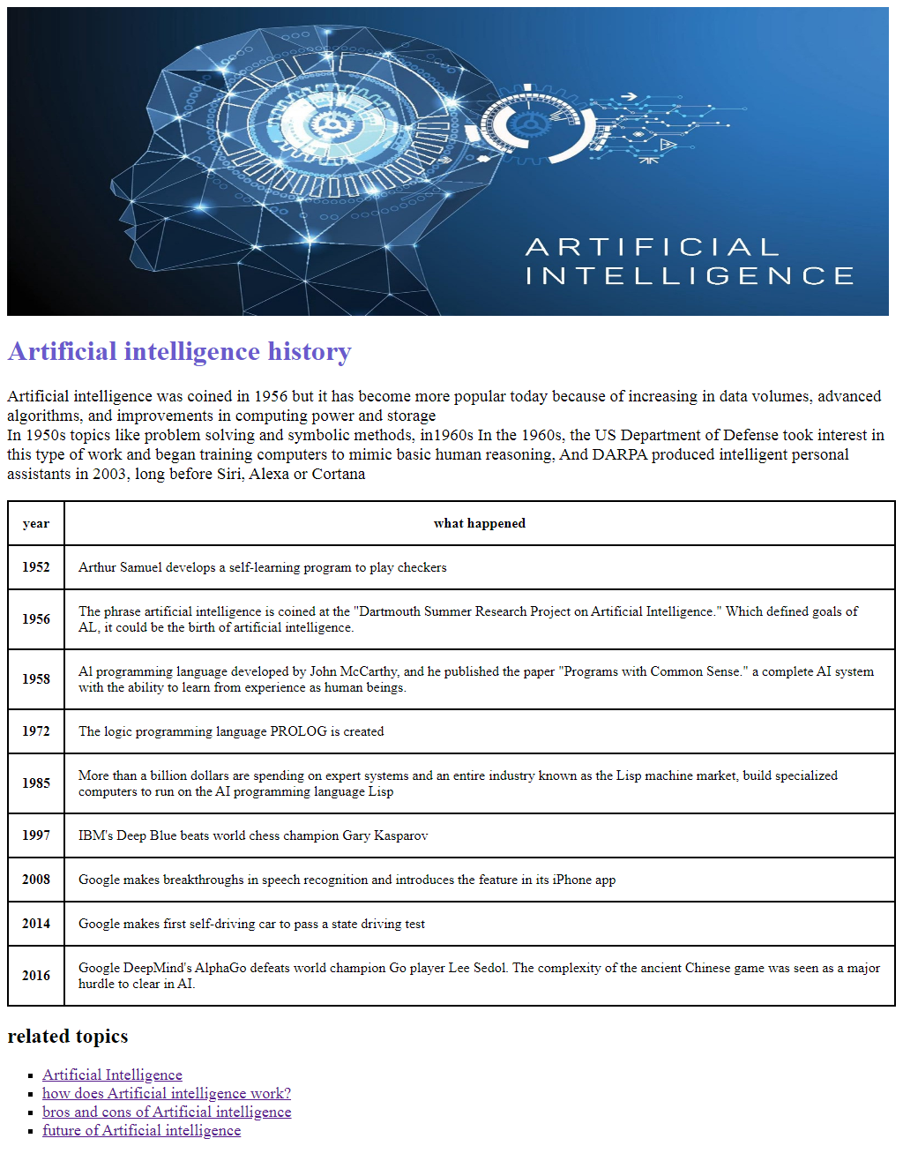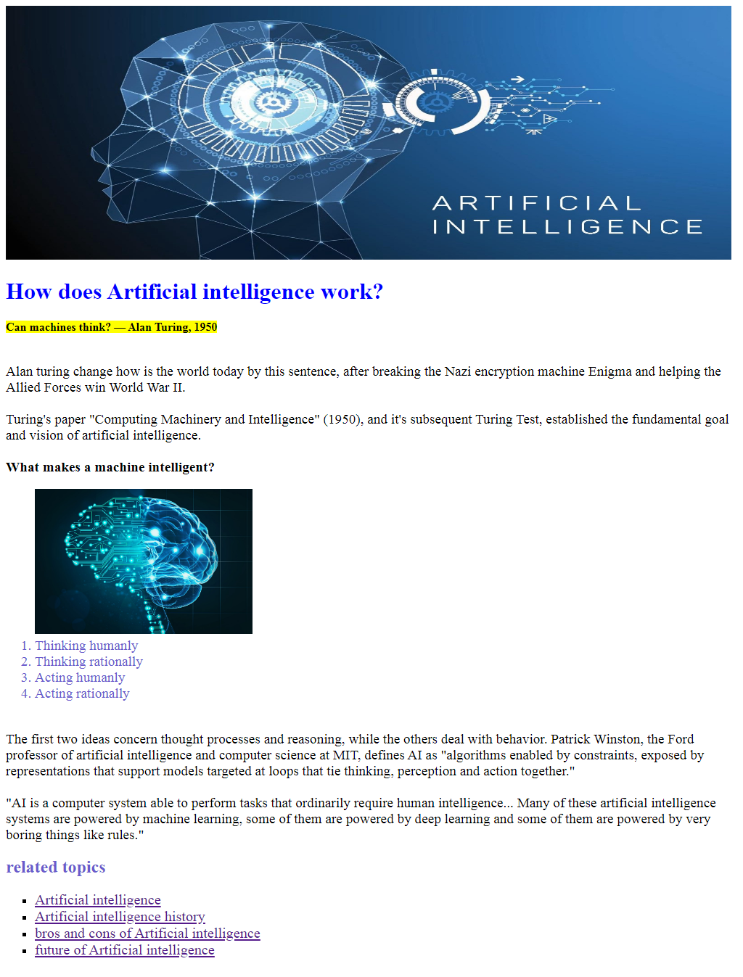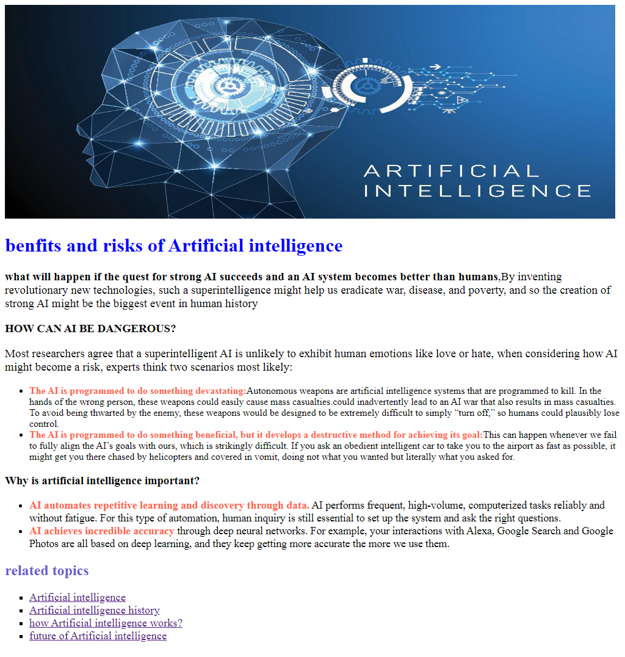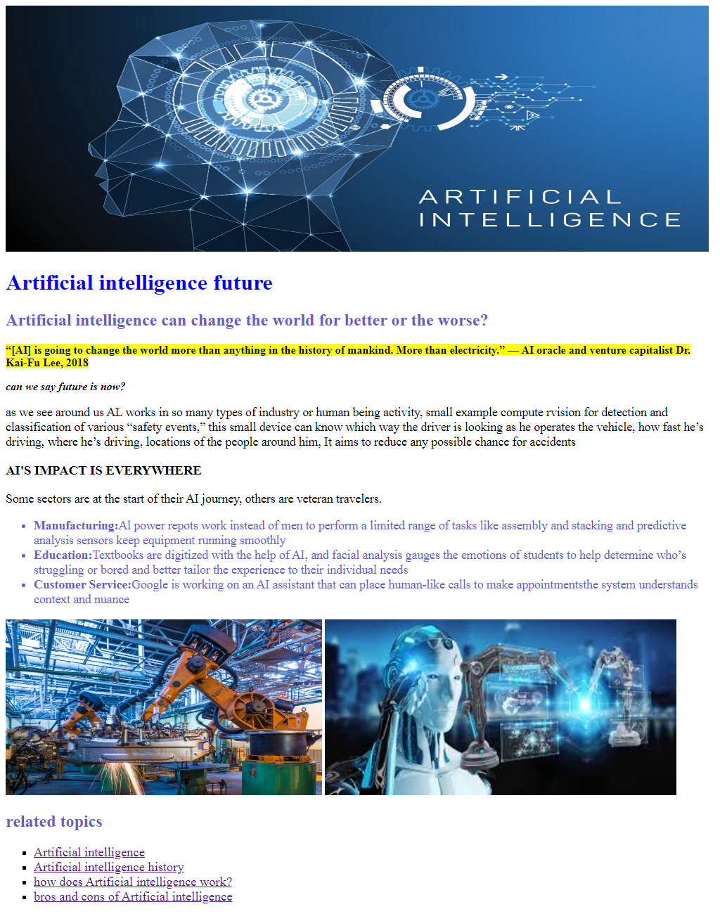

# Website source code

### Artificial Intelligence

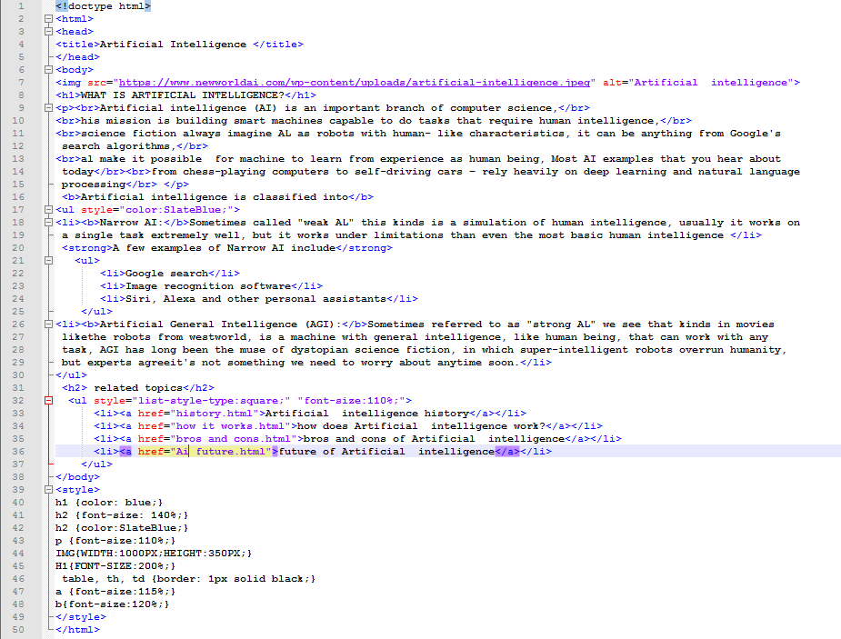

### Ai history

### 

### How does Al work?

### 

### Ai bros and cons

### 

### Ai future

### 